**Assignment 5**

1

Started by user [Ayala Zimner](http://localhost:8080/user/ayala)

Running as SYSTEM

Building on master in workspace C:\Users\User\.jenkins\workspace\Assignment5.1

[Assignment5.1] $ python C:\Users\User\AppData\Local\Temp\jenkins850639302027592621.py

Finished: SUCCESS

**2**

Started by user [Ayala Zimner](http://localhost:8080/user/ayala)

Running as SYSTEM

Building on master in workspace C:\Users\User\.jenkins\workspace\Assignment 5.2

[Assignment 5.2] $ python C:\Users\User\AppData\Local\Temp\jenkins6391568540165163012.py

Ayala

Finished: SUCCESS

**3**

Started by user [Ayala Zimner](http://localhost:8080/user/ayala)

Running as SYSTEM

Building on master in workspace C:\Users\User\.jenkins\workspace\Assignment 5.3

[Assignment 5.3] $ python C:\Users\User\AppData\Local\Temp\jenkins8149210989251508275.py

Free: 8 GB

Finished: SUCCESS

**4**

Started by user [Ayala Zimner](http://localhost:8080/user/ayala)

Running as SYSTEM

Building on master in workspace C:\Users\User\.jenkins\workspace\Assignment 5.4

[Assignment 5.4] $ cmd /c call C:\Users\User\AppData\Local\Temp\jenkins8687326873661586179.bat

C:\Users\User\.jenkins\workspace\Assignment 5.4>move /Y "D:\Python\Test Files\MyName.txt" "D:\Python\Test Files\Moved\MyName.txt"

1 file(s) moved.

C:\Users\User\.jenkins\workspace\Assignment 5.4>exit 0

Finished: SUCCESS

**5**

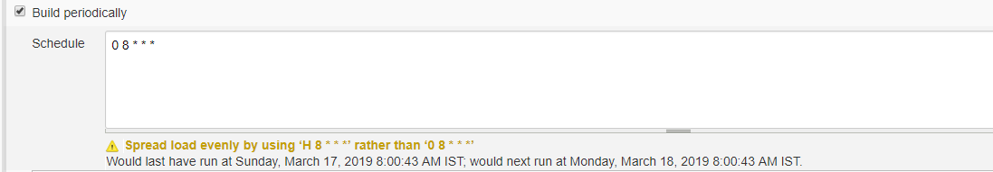

**6**

**Pipeline Script:**

pipeline {

agent any

stages {

stage('Write File') {

steps {

build 'Assignment 5.1'

}}

stage('Read File') {

steps {

build 'Assignment 5.2'

}}

stage('Print Disk Space') {

steps {

build 'Assignment 5.3'

}}

stage('Move File') {

steps {

build 'Assignment 5.4'

}}

}

}

**Console Output:**

Started by user [Ayala Zimner](http://localhost:8080/user/ayala)

Running in Durability level: MAX_SURVIVABILITY

[Pipeline] Start of Pipeline

[Pipeline] node

Running on [Jenkins](http://localhost:8080/computer/(master)/) in C:\Users\User\.jenkins\workspace\Assignment 5 Pipeline

[Pipeline] {

[Pipeline] stage

[Pipeline] { (Write File)

[Pipeline] build (Building Assignment 5.1)

Scheduling project: [Assignment 5.1](http://localhost:8080/job/Assignment%205.1/)

Starting building: [Assignment 5.1 #6](http://localhost:8080/job/Assignment%205.1/6/)

[Pipeline] }

[Pipeline] // stage

[Pipeline] stage

[Pipeline] { (Read File)

[Pipeline] build (Building Assignment 5.2)

Scheduling project: [Assignment 5.2](http://localhost:8080/job/Assignment%205.2/)

Starting building: [Assignment 5.2 #2](http://localhost:8080/job/Assignment%205.2/2/)

[Pipeline] }

[Pipeline] // stage

[Pipeline] stage

[Pipeline] { (Print Disk Space)

[Pipeline] build (Building Assignment 5.3)

Scheduling project: [Assignment 5.3](http://localhost:8080/job/Assignment%205.3/)

Starting building: [Assignment 5.3 #2](http://localhost:8080/job/Assignment%205.3/2/)

[Pipeline] }

[Pipeline] // stage

[Pipeline] stage

[Pipeline] { (Move File)

[Pipeline] build (Building Assignment 5.4)

Scheduling project: [Assignment 5.4](http://localhost:8080/job/Assignment%205.4/)

Starting building: [Assignment 5.4 #2](http://localhost:8080/job/Assignment%205.4/2/)

[Pipeline] }

[Pipeline] // stage

[Pipeline] }

[Pipeline] // node

[Pipeline] End of Pipeline

Finished: SUCCESS

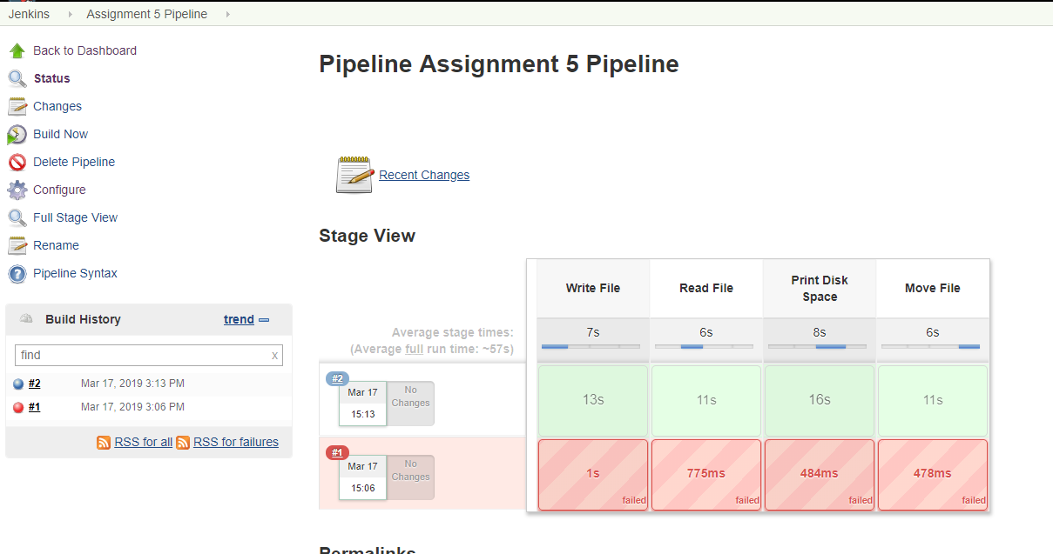

**7**

Not done, I don’t have my Selenium project.

**Challenge:**

